EXERCISE 5
1. List all employees who hold the titles of “Senior Programmer” and “Multimedia Programmer”.
SELECT f_name, l_name, title FROM employee_data WHERE title IN ('Senior Programmer', 'Multimedia Programmer');
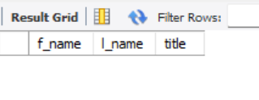

2. List all employee names with salaries for employees who draw between ₱70,000 and ₱90,000.
SELECT f_name, l_name, salary FROM employee_data WHERE salary BETWEEN 70000 AND 90000;
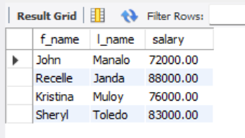

3. What will the following statement display?
SELECT f_name, l_name, title FROM employee_data WHERE title NOT IN ('Programmer','Senior Programmer','Multimedia Programmer');
The first name, last name and job title will display from table employee_data whose job titles are not related to Programming.
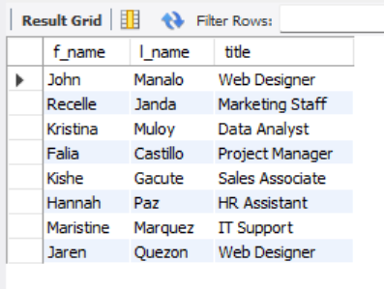

4. Here is a more complex statement that combines both BETWEEN and IN.What will it display?
SELECT f_name, l_name, title, age FROM employee_data WHERE title NOT IN ('Programmer','Senior Programmer','Multimedia Programmer') AND age NOT BETWEEN 28 AND 32;
This displays employees who are not programmers of any type, and not between 28 and 32 years old, it will be under 28 or over 32.
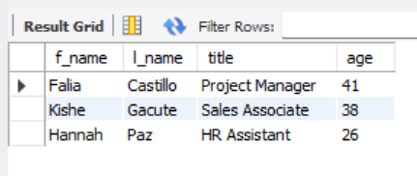

CREATE DATABASE Exercise5_ADDRESSBOOK;
USE Exercise5_ADDRESSBOOK;
CREATE TABLE employee_data (
employee_id INT AUTO_INCREMENT PRIMARY KEY,
f_name VARCHAR(100),
l_name VARCHAR(100),
title VARCHAR(100),
division VARCHAR(100),
age INT,
yearsofservice INT,
salary DECIMAL(10,2),
perks DECIMAL(10,2),
email VARCHAR(100)
);
INSERT INTO employee_data (f_name, l_name, title, division, age, yearsofservice, salary, perks, email) VALUES
('John', 'Manalo', 'Web Designer', 'IT', 29, 3, 72000, 3500, 'aaron.lopez@bignet.com'),
('Recelle', 'Janda', 'Marketing Staff', 'Marketing', 32, 4, 88000, 6000, 'bianca.santos@bignet.com'),
('Kristina', 'Muloy', 'Data Analyst', 'IT', 30, 2, 76000, 4500, 'celine.torres@bignet.com'),
('Falia', 'Castillo', 'Project Manager', 'Operations', 41, 10, 110000, 16000, 'darren.castillo@bignet.com'),
('Sheryl', 'Toledo', 'Programmer', 'IT', 27, 3, 83000, 9000, 'elaine.mendoza@bignet.com'),
('Kishe', 'Gacute', 'Sales Associate', 'Sales', 38, 7, 115000, 19000, 'francis.diaz@bignet.com'),
('Raicelyn', 'Salas', 'Programmer', 'IT', 35, 9, 125000, 20000, 'gwen.reyes@bignet.com'),
('Hannah', 'Paz', 'HR Assistant', 'HR', 26, 1, 58000, 3000, 'hannah.lim@bignet.com'),
('Maristine', 'Marquez', 'IT Support', 'IT', 31, 3, 67000, 3200, 'ivan.ramirez@bignet.com'),
('Jaren', 'Quezon', 'Web Designer', 'IT', 28, 2, 69000, 2800, 'jared.flores@bignet.com');

SELECT f_name, l_name, title FROM employee_data WHERE title IN ('Senior Programmer', 'Multimedia Programmer');
SELECT f_name, l_name, salary FROM employee_data WHERE salary BETWEEN 70000 AND 90000;
SELECT f_name, l_name, title FROM employee_data WHERE title NOT IN ('Programmer','Senior Programmer','Multimedia Programmer');
SELECT f_name, l_name, title, age FROM employee_data WHERE title NOT IN ('Programmer','Senior Programmer','Multimedia Programmer') AND age NOT BETWEEN 28 AND 32;

